BSE20-25

**LABOR OPTIMIZATION SYSTEM**

Software Design Document

**GROUP MEMBERS:**

|  |  |  |  |
| --- | --- | --- | --- |
| **#** | **Names** | **Registration Number** | **Signature** |
| 1 | MUWONGE EMMANUEL | 16/U/7842/PS |  |
| 2 | KISEMBO ERINAH TUMUSIIME | 16/U/6168/PS |  |
| 3 | MUTEBI WILSON | 16/U/7751/EVE |  |
| 4 | SUNDAY DEOGRATIAS | 16/U/11792/PS |  |

**Date: February, 19th 2020**

# 

Table of Contents

LIST OF FIGURES iii

LIST OF TABLES iv

1. Introduction 1

1.1. Purpose 1

1.2. Scope 1

1.3. Overview 1

1.4 Reference Material 2

1.5 Definitions and Acronyms 2

2. SYSTEM OVERVIEW 3

3. SYSTEM ARCHITECTURE 4

3.1 Architectural Design 4

3.2 Decomposition Description 6

3.3 Design Rationale 7

4 DATA DESIGN 8

4.1 DATA DESCRIPTION 8

5. Component Design 9

5.1. User Interface Component 9

5.1.1. Definition 9

5.1.2. Responsibilities 9

5.1.3. Constraints 9

5.1.4. Composition 9

5.1.5. Uses/ Interactions 9

5.1.6. Resources 9

5.1.7. Processing 9

5.1.8. Interface 9

5.1.9. Typical Operation Flow (Pseudo code) 10

5.2. The Machine Learning Predictive Model And Analysis component 11

5.2.1. Definition 11

5.2.2. Responsibilities 11

5.2.3. Constraints 11

5.2.4. Composition 11

5.2.5. Uses/Interactions 11

5.2.6. Resources 11

5.2.7. Processing 11

5.2.8. Interfaces/Exports 11

5.2.9. Typical Operation Flow (Pseudo code) 12

5.3. Data component. 12

5.3.1. Definition 12

5.3.2. Responsibilities 12

5.3.3. Constraints 12

5.3.4. Composition 13

5.3.5. Uses/Interactions 13

5.3.6. Resources 13

5.3.7. Processing 13

5.3.8. Typical Operation Flow (Pseudo code) 13

6. Human Interface Design 14

6.1 Overview of User Interface 14

6.2 Screen Images 14

6.3 Screen Objects and Actions 17

7. REQUIREMENTS MATRIX 18

References 19

# LIST OF FIGURES

Figure 3. 1 Architectural design of LOS 4

Figure 3. 2 Context diagram of LOS 6

Figure 3. 3 Structural decomposition diagram of LOS 6

Figure 6. 1 Login Page of the LOS System 15

Figure6.2 Home Page of the LOS System 15

Figure6. 3 Screen showing workload for a given week 16

Figure6. 4 Data Analysis interface 16

# LIST OF TABLES

Table7. 1Requirements Matrix 18

# 1. Introduction

## 1.1. Purpose

This document's purpose is to provide a high-level design framework around which to build our Labor Optimization System. This document will define the design of the Labor Optimization System. It contains specific information about the expected input, output, classes, and functions. It also provides a list of requirements against which to test the final project and determine whether we were able to successfully implement the system according to design.

## 1.2. Scope

This Design Specification is to be used by Software Engineering and Software Quality Engineering as a definition of the design to be used to implement the Labor Optimization System]. It provides the architecture and design of Release 1.0 of the Labor Optimization System. It will show how the design will accomplish the functional and non-functional requirements detailed in the Labor Optimization System Software Requirements Specification (SRS) document.

## 1.3. Overview

Product Perspective

This product will contain an intelligent model that will help organizations optimize labor at their disposal by making predictions on the workload.

#### Design Method

The design of this product utilizes an object-oriented approach.

#### User Interfaces

The user of this product will be interfacing with the system to help put in some inputs when required. The product allows the user to get familiar with the software with the least computer knowledge.

#### Hardware Interfaces

This software can run on most computers with compatible graphics card which is required due to need of graphical visualization of the analysis.

#### Software Interfaces

This system will execute on all operating systems platform through a browser connected to the internet.

#### Memory Constraints

This program takes up about 7 KB of memory. The output results are modest in size and take up about 7 KB.

#### Operations

The user will be required to enter the parameters/values for the system from the user interface.

#### Site Adaptation Requirements

This software is intended to execute on any operating system platform with no modifications needed to support different sites.

#### User Characteristics

The general characteristics of the intended users are computer literates and people with some knowledge about labor related information.

## 1.4 Reference Material

None

## 1.5 Definitions and Acronyms

1. KB: Kilobytes
2. LOS: Labor Optimization System
3. UBOS: Uganda Bureau of Statistics
4. UI: User Interface
5. GUI Graphical User Interface

# 2. SYSTEM OVERVIEW

The Labor optimization System will provide a solution to the problem of labor underutilization and labor over utilization in many organizations in Uganda which is a problem to businesses.

Labor is a factor of production and therefore it equally affects the growth of a business just as much as any other factors such as capital and land. Labor as a resource is mainly measured in terms of labor productivity which is a key measure for business efficiency. [1] Uganda has lowest labor productivity of 1,085 in comparison to its neighboring countries (Tanzania 2,016; Zambia 2,680; Kenya 3,457) in terms of value added per worker in US dollars. This therefore lowers the economy of the country despite the fact that we are undergoing the industrial revolution. [2] Following the National Employment Policy of the republic of Uganda which states that Increasing Decent Employment Opportunities and Labor Productivity for Socio - Economic Transformation, this much more causes a great need for the improvement of the labor productivity as this is of great importance to both the business and the country at large[3].

The UBOS report suggests use of technology as one of the solutions to the decrease in labor productivity. The LOS system will be developed to provide a solution to the problem in the above paragraph. It will be a web based system with a machine learning predictive model that can predict the amount of work and distribute it basing on the labor available. It will also help in the business analysis[4].

# 3. SYSTEM ARCHITECTURE

## 3.1 Architectural Design

The Labor Optimization System will function in such a way that data is drawn from the database which will then be used to train the predictive model. This predictive model will then predict the possible result for a query made by the user and display the outcome to the user interface. The data shall also be analyzed.

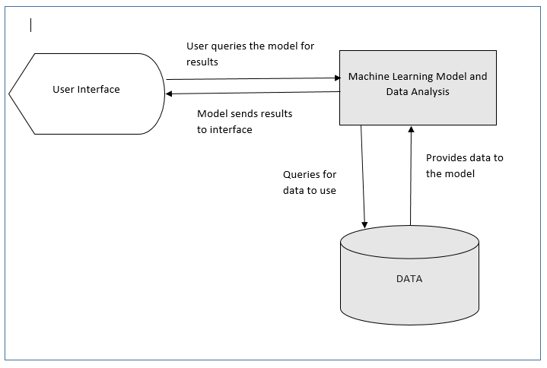

Figure 3. 1 Architectural design of LOS

The System comprises of mainly three modules that is;

**The User Interface:** This is meant to enable the user interact with the system. This will provide the user with a mechanism of querying the system with specific instructions and all displaying the results of the query in a more understandable way to the user.

**Database:** This provides a mechanism with which the data is going to be collected overtime. This is meant to enable the system work and predict with a view of following the current trends in the data.

**The Machine Learning Predictive Model And Analysis**: This is the artificial intelligence setup that is meant to use the data stored in the database to train the model and make predictions about the future that are viable to coming up with necessary decisions in labor management.

**How they work**

The user accesses the user interface and queries the system to do something. The user interface sends the query to the trained model. The model processes the query and sends the result to the user interface where the user views and makes the intended decisions based on the system’s output.

## 3.2 Decomposition Description

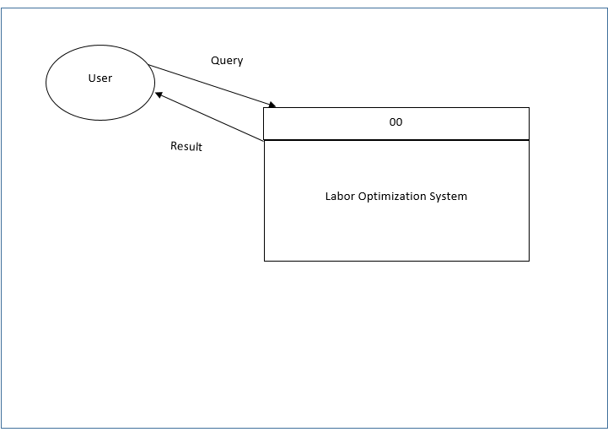

Figure 3. 2 Context diagram of LOS

The user queries the system for prediction or analysis. The system makes prediction or analyses the data and displays the outcome to the user.

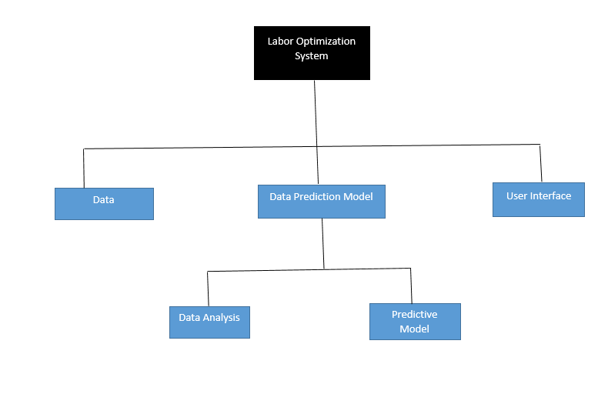

Figure 3. 3 Structural decomposition diagram of LOS

## 3.3 Design Rationale

We used three-tier architecture with a logical layer of the data prediction model and analysis, user interface and data. We chose this architecture because it provides a means of continuous improvement of the model and a means to analyze and predict the outcome before displaying it to the user through the user interface.

# 4 DATA DESIGN

## 4.1 DATA DESCRIPTION

The data will be flowing through three different modules of the system that is the web interface, predictive model and data analysis modules.

Each module will be implemented as a component and it will allow flow of data in and out of the module using various parameters and variables.

The data will be stored in a database and it will be used for analysis and training the predictive model. The data from the database will be first exported to the csv file and then used to train the predictive model at a given interval.

# 5. Component Design

## 5.1. User Interface Component

### 5.1.1. Definition

A component that displays detailed results from analysis conducted. It also displays the results from the predictive model component.

### 5.1.2. Responsibilities

* Display analysis and prediction results.
* Provide interface for end user interaction with the system.

### 5.1.3. Constraints

* Requires a browser
* Changes made here shouldn’t affect the system.

### 5.1.4. Composition

Contains graphs and statistical figures.

### 5.1.5. Uses/ Interactions

This component interacts with the Predictive model and analysis module.

### 5.1.6. Resources

* Hard disk
* RAM
* Processor

### 5.1.7. Processing

Here analysis results are graphically displayed on the monitor for the users to view. Queries generated by user clicks are transferred to the Predictive model component for response generation.

### 5.1.8. Interface

A graphical user interface with clickable buttons and menus are provided to facilitate user friendliness and interactions with the end users.

### 5.1.9. Typical Operation Flow (Pseudo code)

User selects display type;

If analysis results is selected;

User selects analysis results type;

If statistical table is selected;

Render Table;

If graph is selected;

Render Graph;

Else if predictive results is selected;

User selects preferred time range;

Render Predictive Output;

When user is done;

Close Session;

## 5.2. The Machine Learning Predictive Model And Analysis component

### 5.2.1. Definition

This component conducts analysis on the dataset and also performs machine learning aided predictive modeling.

### 5.2.2. Responsibilities

* Import dataset from where they are stored.
* Create new datasets from existing ones.
* Conduct analysis on imported datasets.
* Perform relevant predictive modeling.

### 5.2.3. Constraints

* Only accessible to developers.
* Requires availability of reasonable space on Main Memory.

### 5.2.4. Composition

It has machine learning and analysis scripts.

### 5.2.5. Uses/Interactions

It imports data from the Dataset/Database component and displays analysis and prediction result in the User Interface component.

### 5.2.6. Resources

* Hard disk storage
* RAM
* Processor

### 5.2.7. Processing

Machine Learning and analysis scripts are executed to produce results.

### 5.2.8. Interfaces/Exports

The main interfaces here are the script window and the console. The exported item from this component is analysis and prediction results to the User Interface component.

### 5.2.9. Typical Operation Flow (Pseudo code)

Fetch dataset from where it is stored;

Clean dataset;

Perform statistical analysis to get general outlook and overview of the dataset;

Use past workload information to predict the amount of workload over a range of time period that is on a particular day, in a week, in a month; (All these options have to be available for the user selection during interaction.)

Use workload to predict which areas might need man power improvement and in what quantity;

Render analysis results in tabular and graphical formats;

Render prediction results;

When user is done;

Close Session;

## 5.3. Data component.

### 5.3.1. Definition

This component contains the dataset(s) to be analyzed.

### 5.3.2. Responsibilities

Store the data. It acts as a feeder to the Machine Learning Predictive Model And Analysis component.

### 5.3.3. Constraints

* Requires physical storage space.
* End users can’t interact with this component. This is to avoid them altering the content of the dataset

### 5.3.4. Composition

It contains dataset.

### 5.3.5. Uses/Interactions

It interacts with the Machine Learning Predictive Model And Analysis component that imports the dataset from data component.

### 5.3.6. Resources

It uses the physical storage (The hard disk).

### 5.3.7. Processing

The datasets are imported from it using scripts written in the Machine Learning Predictive Model And Analysis component.

### 5.3.8. Typical Operation Flow (Pseudo code)

Establish Database Connection;

Fetch Data;

Close Connection;

# 6. Human Interface Design

## 6.1 Overview of User Interface

The landing page is the login page that authorizes and authenticates users into the system. From the login page, the user can reach the home page only after successfully logging in. From the home page, the user can reach several other pages that include: data analysis, help and workload pages. All these pages cover necessary functionality of system. It is easy to navigate between these pages. User constantly has access to all pages through the menu on top of each page. Each page has its own menu on the left side of the page, which contains all required operations that could be performed with that page.

Login page has descriptive characters; it contains a list of main system’s functionality and contact information. After login, Home page is displayed and guides user on how to work with system. Home page covers main functionalities of the system.

## 6.2 Screen Images

Used GUI components are menus, submenus, buttons, textboxes and checkboxes, down drop lists, links, and tables. The only means of access to the entire system, by all users, is through this UI. Some examples of UI are presented below:

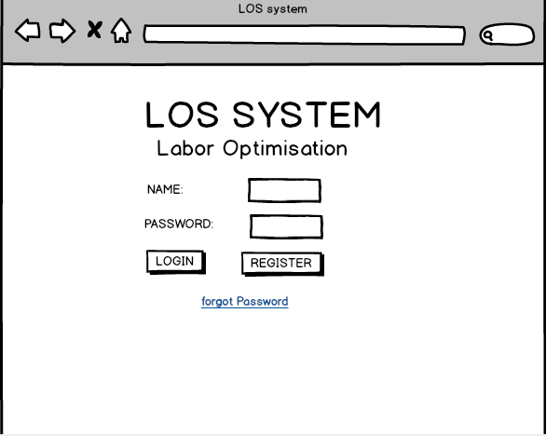

Figure 6. 1 Login Page of the LOS System

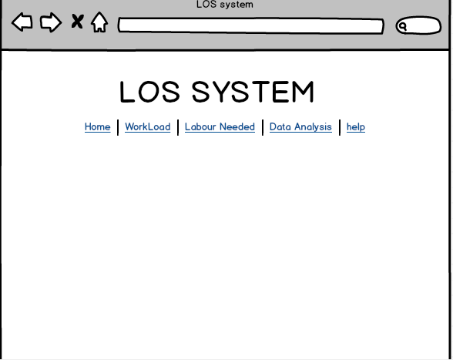

Figure6.2 Home Page of the LOS System

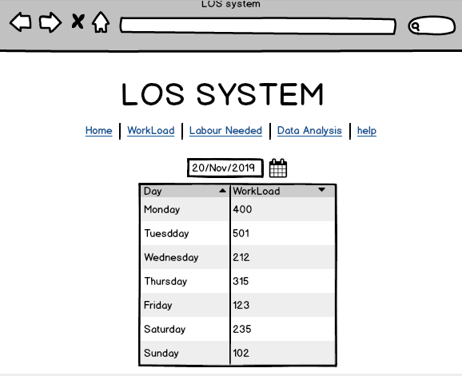

Figure6. 3 Screen showing workload for a given week

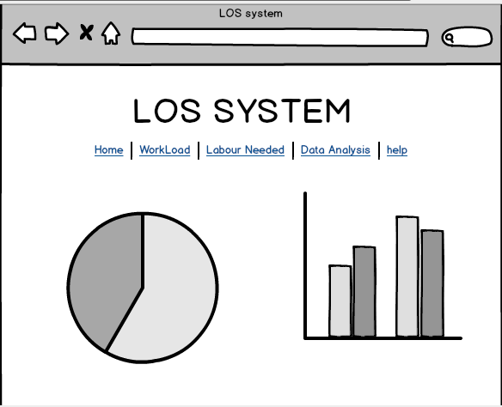

Figure6. 4 Data Analysis interface

## 6.3 Screen Objects and Actions

In the Login page, user provides login and password in appropriate text boxes and confirms this operation by clicking on Login button.

After logging in, Home page is available to user. It contains following menu: Home, Workload, Data Analysis and link to Logout the current user. User clicks on necessary item in the menu in order to navigate to the next page.

Workload Page has a time menu (Days, Weekly and Monthly) on left side of the page and a text input to specify the quantity of the time for which the prediction can be made. When any of the menus is clicked, a predictive machine learning model is invoked to make predictions. The prediction results are displayed on the interface in a well formatted table.

Data analysis page has a menu of three (3) items (Graphs, Tables, Numbers) on left side of the page.

# 7. REQUIREMENTS MATRIX

Table7. 1Requirements Matrix

|  |  |
| --- | --- |
| REQUIREMENTS | SYSTEM COMPONENTS |
| LOS shall predict the workload expected by the organization for a specific period of time | The Machine Learning Predictive Model And Analysis Component |
| LOS shall analyze some of the data recorded overtime | The Machine Learning Predictive Model And Analysis Component |
| LOS shall allow an Admin to register users | User Interface Component |
| LOS shall allow users to login | User Interface Component |

# References

[1] G. Ssemogerere, *Productivity Performance in Developing Countries*. 2009.

[2] *THE NATIONAL EMPLOYMENT POLICY FOR UGANDA*. .

[3] “No Title.” [Online]. Available: https://newz.ug/uganda-will-not-achieve-middle-income-status-with-the-current-low-labour-productivity/.

[4] Ubos, *Report national labour force survey*. 2017.